Name: ____________________________________________________ Date: ___/___/___ Period: ____

Enzyme Pathway Simulation

Introduction:

Enzymes speed up chemical reactions by lowering activation energy (that is, the energy needed for a reaction to begin). In every chemical reaction, the starting materials (the substrate(s) in the case of enzymes) can take many different paths to forming products. For each path, there is an intermediate or transitional product between reactants and final products. The energy needed to start a reaction is the energy required to form that transitional product. Enzymes make it easier for substrates to reach that transitional state. The easier it is to reach that state, the less energy the reaction needs.

Within the cell are many enzyme pathways that use several types of enzymes. Each enzyme uses the product of one reaction as the substrate for its own reaction. The end product in this series of reaction will look much different than the starting substrate because of the many enzymes working together. In the lab activity, you will be completing today, you and your group members will act as an enzyme in a pathway.

**Directions:** Each person in your group will represent one of the enzymes in a pathway. There are three major rules for activity:

1. REMEMBER that you ARE an enzyme that cannot think by itself. You do not communicate with the other enzymes. Move around to look for your substrate.
2. Only do your action upon your substrate. You can NOT work on substrates that are not EXACTLY as they appear in your reaction.
3. If you can’t operate upon a particular substrate, move it on to another person or another table.  If you start to see a pile showing up on a table, you can pick it up and “diffuse” it to another table or person.

**Post Lab**

1. 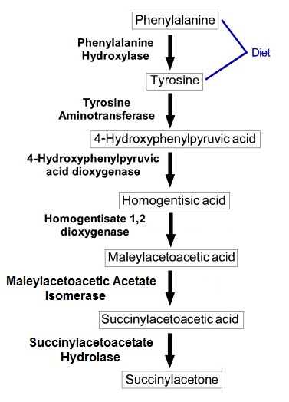Were there any times in your group where a product started to backup and form a pile? Why did this happen or not happen?
2. What happened when one of the enzymes was taken out/inhibited? What would occur in the body if this happened?
3. To the right is an enzymatic pathway of the breakdown of phenylalanine and tyrosine. In the disorder Alkaptonoria, there is a mutation on one of the genes that codes for one of the enzymes in the pathway. Find out which enzyme is mutated and draw and X over the enzyme. Next circle the product that builds up in our cells on the pathway. Lastly, describe what happens to a person that has this disease. What are their symptoms?